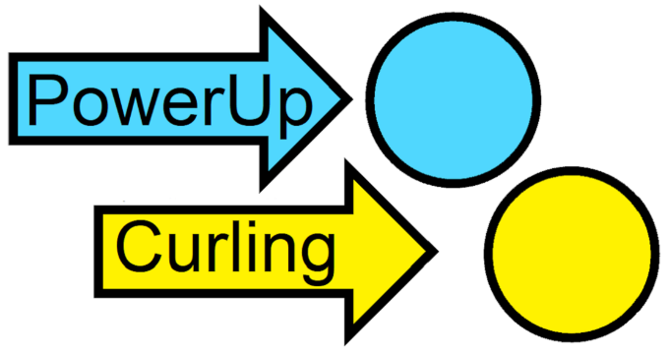
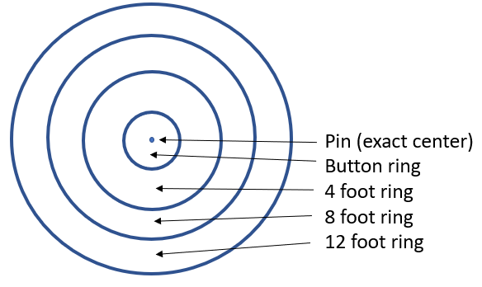
“The House” (diagram #1)

Number of players: 2-8 split into two teams as evenly as possible.

Approximate Time to Play: 45-60 minutes
Objective:
Your curling team is trying to score more points than your opponent team by strategically playing your cards to place as many of your "stones" (a set of 4 cards) as close to the “pin” as possible and in front of your opponet’s closest stone to the pin. This will most likely involve playing offensively and defensively. If you play the best card in your hand every shot, your team will likely lose.

Set Up:
- Place the green “pin” card at one end of the table.
- By a random method determine which team goes last – give that team the red “hammer” card. The other team gets to go first and they also get to pick which color deck (blue or yellow) they want to be.
- Decide which player on each team is going to go first. Give them the corresponding colored “skip” card. This card will rotate among team members each stone they throw.
- Deal out the cards of each deck to the players on that colored team. See “# of Players” (Diagram #3 near the back) to determine how many cards each person gets.

Quick explanation:
Cards are ranked: The “button” card is better than the 4ft card which is better than the 8ft card which is better than the 12ft card.
The first person who plays a card on a team is the "Skip". S/he plays a card face up. S/he is calling for a specific shot to be made. The rest of the team tries to complete that shot successfully by each playing an additional card one at a time. Any one of the three cards must "make" the shot and the remaining two cards determine how good a shot it was. If the shot is not made, then the four cards are discarded. The four cards together comprise the “stone”.
(2)
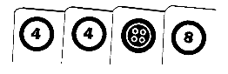
“House Stone” example:
If a 4, 8, button, and another 4 were played in that order, it is a good shot that lands up in the 4 foot ring because the call was a 4 (the first card) and someone played a 4 (it so happened to be the last card played). The button card and the 8 card indicate how good of a 4 ft shot it is. The cards are then arranged to be 4,4 and then in rank order; b,8 and then placed on the table amongst other stones in closest order from the pin card.
“Action Stone” example:
If the call is to make an action shot (Guard or Hit) the Skip must play one of those cards and indicate what the target of the action is. One of the remaining players must play a card that matches the target.
For example; the Skip calls for a hit on the opposing team's only stone (b,b,4,12) in the button ring …
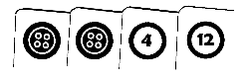
<< Target (the opponent’s button stone)

… by playing an H card and announcing the target. The rest of the team then plays a 12, a 4, and another 4.
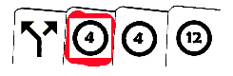
<< Failed Hit attempt

The hitting team did not play a card that matched the target (i.e. a button) so the hit attempt failed and the stone (H,4,4,12) is discarded.
The teams alternate attempting shots until each team tries 8 times. At that point the "end" is over and the stones are scored. There are three ends in a game and the scores from each end are tallied for the final scores for the teams. (3)
For more details about actions and rankings, please see the cards themselves and the more detailed rules which follow.

Decks:
Two similar 61 card decks; one blue, one yellow.

Icon | Card | Freq. | Description
 | button (b) | 8 | House Card or PowerUp Modifier
 | 4 | 12 | House Card or PowerUp Modifier
 | 8 | 13 | House Card or PowerUp Modifier
 | 12 | 14 | House Card or PowerUp Modifier
 | Guard (G) | 6 | Action Card
 | Hit (H) | 6 | Action Card
 | Wild | 1 | Can be any of the above
 | Skip | 1 | Given to person calling the shot
 | There is only one red hammer card. Give it to the team that throws the last stone in each end.
 | There is only one green pin card. Place it at one end of the table. Try to throw your stones closest to it.

The Decks (diagram #2)
(4)
House Stone Positioning and PowerUp Modifier Rankings:
A "stone" is a set of 4 cards [1,2,3,4] aka [the "Call", the "Shot", best PowerUp modifier, another PowerUp modifier]. Described in this doc as [1,2,3,4] or 12.34 or 1234.

Card rankings: b > 4 > 8 > 12. The Action Cards have no rank and the Wild card has the rank of what it is pretending to be. One card of a higher rank beats a pair of a lower rank, e.g.
[b,b,4,12]

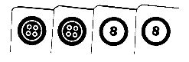
beats

[b,b,8,8]. This is not poker!

Order matters - the first two cards of a "stone in the house" are always paired and indicate what ring the stone is in. The 3rd and 4th cards should be arranged in rank order. That is, [b,b,12,12] is completely different than [12,12,b,b], and [4,4,8,b] should be listed as [4,4,b,8] because a (b)utton PowerUp modifier is greater than an 8 PowerUp modifier.

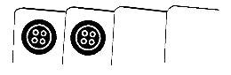
See “The House” diagram on page 1. The first two cards of a "stone in the house" determine where it is in play.
[b,b,,] is in the button ring, [4,4,,] is in the 4 foot ring, etc. Each of the four rings of the house has 10 positions inside for a total of 40 different distances from the pin.
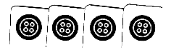
A [b,b,b,b] stone is the closest to the pin and a
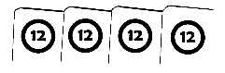
[12,12,12,12] stone is the most distant.

(5)
Order of play:
(see “Alternate Rules” if you want to)
- In the first “end”, a random method is used to determine which team goes last and that team gets the hammer card denoting this. The other team gets to choose which color deck they want to use for the entire game. For each subsequent end, the team that scored in the previous end goes first. The team that did not score goes last and gets the hammer card indicating that they have the last shot.
- At the beginning of each end the teams must announce who will be the "Skip" to start with. The "Skip" title, position, and display card then rotates clockwise amongst team members every stone they throw.
- For 8 players (see alternate rules): 6 cards are dealt to each team member from their deck. The remainder of the deck is placed face down and becomes the draw pile for that team. Players should not tell, hint, or show to any player what they have in their hands.
- All at the same time, each teammate can select one card from their hand and pass it to the teammate on their left. This passing is only done once, at the beginning of each end before the first stone is thrown.
- The Skip (see #2) lays down the first card of the stone face up. This card is "the call". If this is an action card, they must announce the target of the action.
- The rest of the team, one at a time, clockwise starting from the Skip’s left, plays a card face up.
- The team then decides which of the 2nd, 3rd, and 4th cards played is going to be "the shot", the card that goes together with “the call”. The remaining cards are placed in PowerUp modifier rank order to complete the stone [the "Call", the "Shot", best PowerUp modifier, another PowerUp modifier].
- Each person from the team that just threw a stone draws one card from their deck so they maintain 6 cards in their hands.
(6)
- The thrown stone can result in; it being placed in the house (potential to score), an attempted an action, or it being discarded.
- The other team now throws a stone (go to step 5). This repeats until 16 stones are thrown.
- Each team throws 8 stones in an end. At the conclusion of each end, scoring is performed.
- There are 3 ends in a normal game, 6 ends in a tournament game.

Throwing a "House" stone:
If the first person (Skip) plays a "house" card (Diagram 2) face up:
- The goal for the rest of the team is to come up with at least one more card that matches “the call” in order to wind up "in play" by laying down one house card at a time face up, for each remaining players on the team.
- If no one else on the team can match the Skip's card, then the shot was missed, and the stone is out of play. It (the set of 4 cards) is discarded regardless if there is different matching pair laid down by the 3 remaining players.
- If team members 2, 3, or 4 plays an action card, the shot is missed, and the 4 cards are discarded.
- Valid house stones are placed on the table (so all cards in it can be seen) in order [the "Call", the "Shot", best PowerUp modifier, another PowerUp modifier] in relation to the other stones in play in a way that indicates how close to the pin they all are and where they are in relation to each other – ahead, behind, or tied.

Throwing an "Action" stone:
If the Skip plays an "action" card, either a “G”uard or a “H”it face up:
- They must indicate what action they want to take (see below) and what the target stone of that action is before any of their teammates lay down cards 2, 3, or 4. (7)

Guard Action:
The Skip plays a "G" card and indicates an unguarded stone on either team as the “target”.
- You cannot guard nothing and cannot guard a guard.
- One of the remaining team members must lay down a card with the same position as the indicated target stone. If no one can, then the guard action is missed, and the thrown stone is discarded (all 4 cards).
- If a teammate can match the same value as the indicated target stone, the other two cards must be PowerUp modifiers and indicate how good of a guard it is. The guard stone is laid in some fashion over/near the indicated target to show that it is guarded but in such a way as to be able to read all 8 cards.

Hit Actions:
There are three types of "hits"; “take out”, “promote”, and “nudge”

Take Out Action:
- Removes an unguarded stoned on either team.
- You cannot take out any stones until after the third stone of the end is thrown (the 4th stone can be a take out).
- The Skip plays an "H" card and says this is a TAKE OUT and indicates a target stone in play. One of the remaining team members must lay down a card with the same value as the indicated target stone. If no one can, then the take out action is missed, and the thrown stone is discarded (all 4 cards).
- If a teammate can match the same value as the indicated target stone, then the remaining two cards must be of equal or higher PowerUp rankings than the target's 3rd and 4th cards. If they are, the take out is successful and both stones are removed from play. If the 3rd and 4th cards of the thrown stone do not have an equal or higher PowerUp ranking than the 3rd and 4th cards of the

(8)
indicated target stone, then the take out failed and only the thrown take out stone is discarded.

Promote Action:
- Changes the ring rank of one of your team’s unguarded stones already in play.
- You can promote a guard to be a house stone but not a house stone to become a guard.
- The Skip plays an "H" card and says this is a PROMOTE and indicates a target. One of the remaining team members must lay down a card with the same value as the target stone. If no one can, then the promote action is missed and the thrown stone is discarded (all 4 cards).
- If a teammate can match the same value as the indicated target stone, then the remaining two cards of the promote stone must be a matched pair which replace the 1st and 2nd cards of the indicated target stone. The target stone is then re-arranged and place appropriately. The extra cards from both stones are discarded.

Nudge Action:
- Changes, for better or worse, the PowerUp modifiers of any unguarded stone already in play on either team.
- You can nudge guards
- The Skip plays an "H" card and says this is a NUDGE and indicates a target. One of the remaining team members must lay down a card with the same value as the indicated target stone. If no one can, then the nudge action is missed, and the thrown stone is discarded (all 4 cards). If a teammate can match the same value as the indicated target stone, then the remaining two PowerUp modifier cards of the nudging stone (#3 & #4) replace the 3rd & 4th PowerUp modifier cards of the indicated target stone. The extra cards from both stones are discarded.

(9)
- Note: this may mean that a stone is made up of a combination of two different decks. When the end is over, place the cards in the correct decks!

Scoring:
At the conclusion of an end (after 16 stones are thrown):
- Remove all guard stones from play. They are not counted in ties.
- A point is awarded for each stone of the team whose stone(s) are closest to the pin before the best stone of the opposing team.
- Ties (stones the same distance from the pin) – Whichever team has more buttons in play wins the tie, if same # of buttons, then count 4’s, then 8’s etc.
- Points from each end are tallied. Only one team scores per end. At the conclusion of the game, the team with the most points wins.

Miscellaneous Notes:
- If the Skip has only action cards in their hand and there are no stones they can target, then s/he may discard as many cards from his/her hand as they want, draw the same number, and then continue with their turn. If all action cards are re-drawn then the team forfeits their turn.
- If the draw pile for a team is exhausted before the end of the round, the existing discarded cards for that team are shuffled and re-used.
- If a stone is nudged by an opposing team, the stone is still “owned” by the first team and can score for them.

(10)
Strategy Hints
- A team may want to guard a stone of the opposing team so they have a harder time promoting/nudging it to a better position.
- Nudge your opponents’ stones if they have button PowerUp modifiers – helps you win if there is a tie.
- You do not always have to play your "best" card every shot. You may want to save the better PowerUp modifiers cards for when you are the Skip or save them to play on your team’s final stone in the end. i.e. Think twice about playing a button PowerUp modifier on a 1212 house shot unless you are planning on promoting the stone later.

Examples
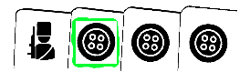
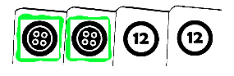
- Guard examples:

A Gbbb can guard a bb1212 fairly well (until the take out example below).

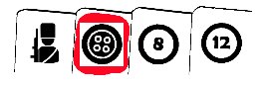
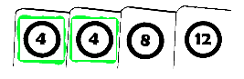
Another attempted guard example:

The Skip plays a Guard card and indicates s/he wants to guard an existing "4" stone. The other teammates play 12,8,b. The guard action is missed because the teammates did not play a "4" matching the target stone. The guard stone (set of 4 cards - Gb812) is discarded.

(11)
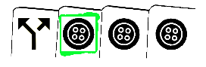
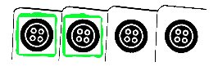
- Successful Take out examples:
a Hbbb removes an unguarded bbbb target stone.
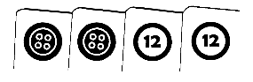
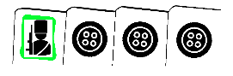
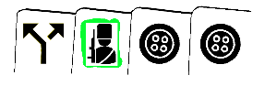

a HGbb removes a Gbbb target stone.

- Promote examples:
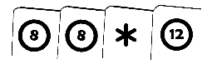

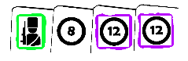
existing stones >
target stone >

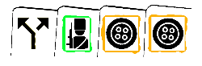
promoting stone >

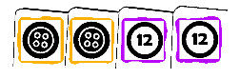

resulting promoted stone >
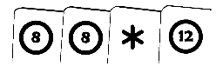
existing stone remains >
(now unguarded)

Explanation: a HGbb thrown stone can promote a guard G81212 target to position bb1212 and the HG of the thrown promote stone and the G8 cards of the target stone are discarded.

(12)
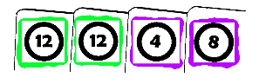
Another promote example:

existing target stone >

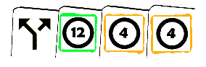

promoting stone >

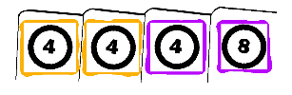
resulting promoted stone >
(a combination of the two)
(extra cards discarded)

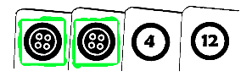
- Nudge example:

existing target stone >

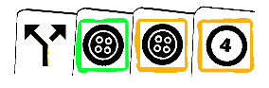

nudging stone >

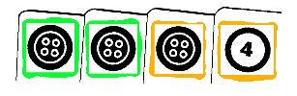
resulting nudged stone >
(a combination of the two)
(extra cards discarded)

(13)
Another nudge example:
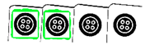
existing target stone >

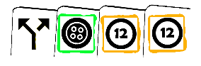

nudging stone >

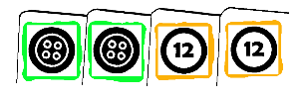
resulting nudged stone >
(a combination of the two)
(in a WORSE position now)

Alternate Rules:
- Allow more frequent passing of card(s) to teammates.
- Do not allow take outs, only promotes and nudges.
- Allow Double take outs (a stone and its guard): Skip plays H, indicates the guarded stone as the target. The take out PowerUp modifiers must be greater than both the guard’s and the target’s PowerUp modifiers.
- If the same person is drawing more than one card and all action cards are drawn, they have option of keeping all drawn cards or discarding all drawn cards and drawing again.

(14)
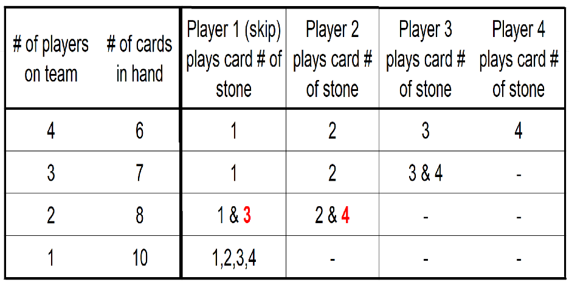

# of Players (diagam #3)
(15)

Acknowledgements:
- Thanks to my wife, Linda Kirkman, for all of the encouragement.
- Thanks to all the play testers at the Potomac Curling Club and the Denver Curling Club.
- Card face icon graphics made by Freepik from www.flaticon.com.

Info:
- If you have any comments, suggestions, or questions, please send an email to powerupcurling@gmail.com
- Cards might smell when first opened due to the high quality plastic coating on them. The smell will dissipate over time.
- If you would like to bulk order this game with your club’s logo on the backs of the cards, let us know!
- If you would like to order this game, please go to powerupcurling.com.

“PowerUp Curling” is ©2019 Russell Kirkman. All rights reserved.

